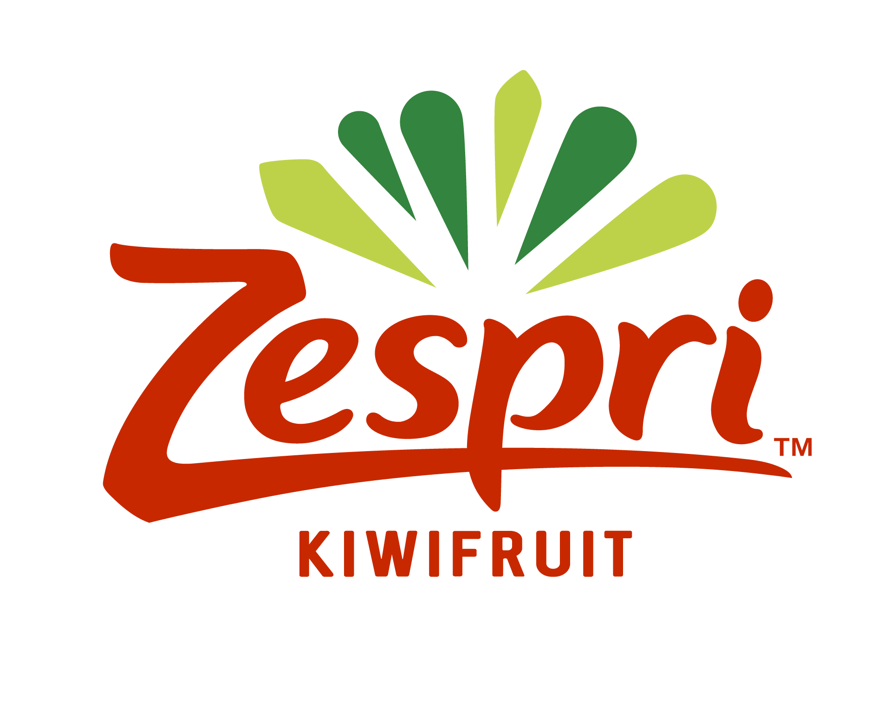
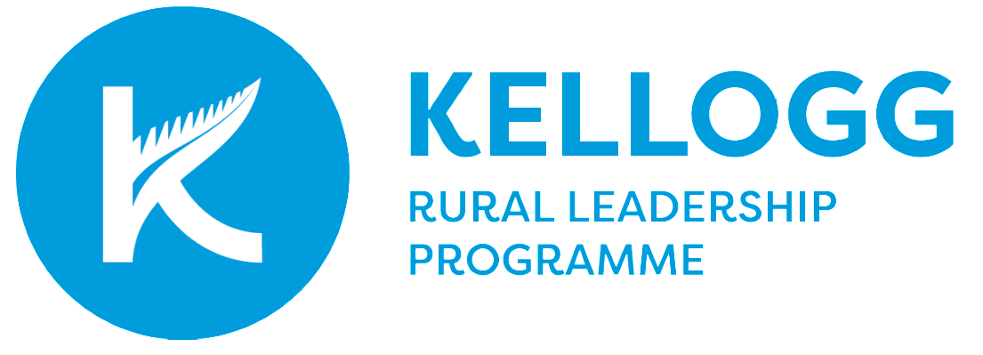

2024 Zespri Kellogg Rural Leadership Programme Scholarship

Referee Statement

As a referee you are asked to provide a short referee statement for a person who has applied for selection for the Kellogg Rural Leadership Programme.

The programme is for people in the primary industry sector in New Zealand, who have indicated their desire to undertake leadership development. The nature of the programme, requires individuals to work under pressure and to work closely as a group of colleagues.

Your feedback will help us to gain an external perspective of the applicant, their goals and potential.

Please complete this form (below) and email to scholarships@zespri.com

Applications must be received by the application closing date*

Application Closing Date – 11 April 2024

* Please note a late referee statement may affect consideration of the application.

2024 Zespri Kellogg Rural Leadership Programme Scholarship Referee Form

SECTION 1: PERSONAL INFORMATION

Full Name:
First /Given Name Surname
Address:

Phone: Mobile:

Email:

Name of Applicant:

Please complete the following questions (up to 500 words maximum). The boxes will expand to accommodate your answers

How long have you known the applicant and in what context?

What do you see as the leadership qualities that the applicant has?

What do you see as the leadership areas the applicant could develop to be more effective?

How do you think the Kellogg Programme would benefit the applicant, their work and their leadership goals?

Please return this form to scholarships@zespri.com
no later than:

Thursday 11 April 2023

