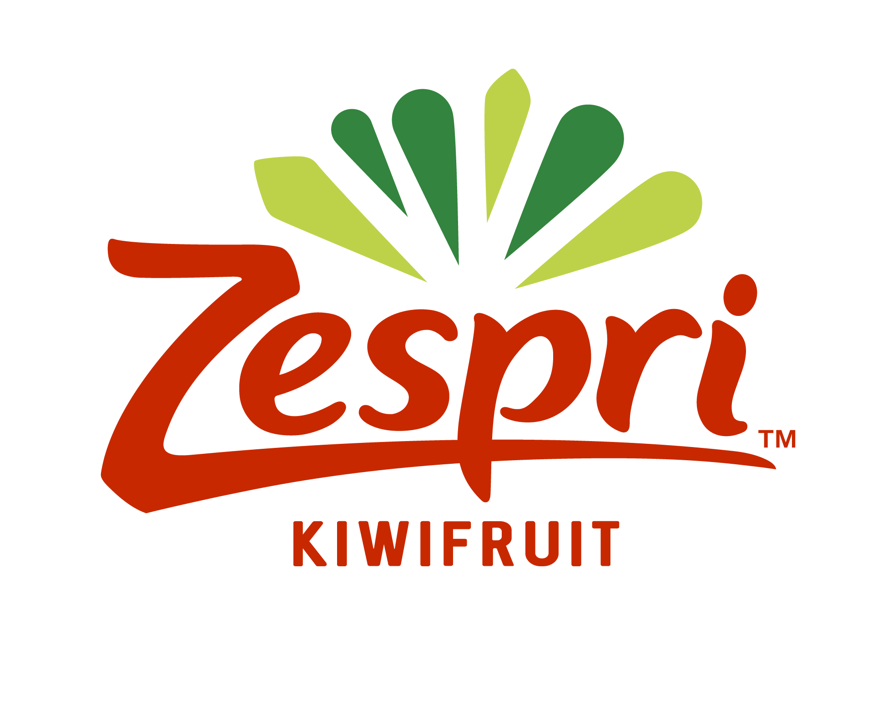

2024 Zespri Kellogg Rural Leadership Programme Scholarship Application

Application Process
Applicants are required to complete all sections of the application form. Please provide complete information as this is the basis for the selection panel to determine your suitability, potential and aspirations to be a leader.

To complete your application please:

- Fill in this application form
- Ensure your two referees complete the referee form
- Email the completed application form, referee form and attachments to scholarships@zespri.com

Applications must be received by the application closing date.

Application Closing Date – 11 April 2024
For more information email scholarships@zespri.com

2024 Zespri Kellogg Rural Leadership Programme
Scholarship Application Form
SECTION 1: PERSONAL INFORMATION
Full Name:
First /Given Name Surname
Address:
___________________________________________________________________
Phone: Mobile:
Email:
Date of Birth: Age:
Iwi: _______________________________________________________________
Nationality:
Please complete the following questions (up to 500 words maximum). The boxes will expand to accommodate your answers

Education Qualifications
Please state relevant educational qualifications and year attained (most recent first)
Year | Qualification
Scholarships and Awards
Please list any scholarships or awards received if applicable (most recent first)
Year | Qualification

Professional /Employment History
Please list your employment/professional details (most recent first)
Year | Position | Organisation

Referees
Please provide the details of the two (2) Referees who will be forwarding referee statements for you reflecting on your industry, personal and community involvement and activities.
Name | Position | Organisation | Phone | Mobile | Email

SECTION 2: Industry & Community Background
Please list (most recent first) any industry or community leadership roles
Year | Organisation | Your Role | Activities/ Achievements
Please provide details of any previous leadership training/programmes undertaken (if applicable)
Year | Programme | Outcomes

How did you learn about the Kellogg Programme? E.g. advert, personal recommendation, email

SECTION 3: ASPIRATIONS
What are your reasons for applying for the Kellogg Programme?
What qualities or skills do you currently have that you believe will make you a potential leader in the rural sector?
Please list your career, community or leadership goals for the next 2-3 years (no more than 100 words)

Privacy Statement
Your personal information is supplied for the purposes of application for this programme and sponsors. Your prior permission will be sought before disclosing it to others not involved with selection and administration of the programme.

DECLARATION
I declare that the information I have provided in my application is a true and accurate record.

I agree to my referees being contacted.

I agree to the privacy statement

Signature: ____________________ (Scanned signature acceptable)
Date: / /

Application Checklist
Before submitting your application check you have included the following;
☐ Completed application form, converted to a PDF if you wish
☐ Passport JPEG photo attached
☐ Referee (x2) contact details included

Please read the instructions at the front to ensure you have completed and attached all that is required and then email (or post) your completed application to scholarships@zespri.com no later than: Thursday 11 April 2024

